Eastern Shore Community College

Employee Information Technology Handbook

**Table of Contents**

ESCC Network Account Quick Facts 3

Overview 3

What is my username and password? 3

What happens if I forget my password? 3

How long does it take to get access to a computer? 3

Which computers may I use? 4

What can I do with my account? 4

What software can I use? 4

Can I install any of the software at home? 5

How do I access my email? 5

How can I get help or more information? 5

Can anyone else use my account? 6

How long will my computer access be valid? 6

How do I report errors in my network account setup? 6

How to Log Into MOAT Security Awareness Training 7

How to Log Into the ESCC Network 8

How to Connect to a Network Share 9

**How to** **Disconnect a Network Drive 10**

How to Log Into My ESCC 11

# ESCC Network Account Quick Facts

## Overview

Eastern Shore Community College’s local area network (LAN) is attached to the Virginia Community College System’s wide area network (WAN) via a fast, always-live Internet connection. Depending on your position, you will have access to one or more of the systems available on the LAN and the WAN.

## What is my username name and password?

For ESCC employees, your LAN username/login is usually your first initial and last name. You will be informed if your username is an exception to this rule.

Your temporary password will be provided to you in your New Employee Information Packet.

This username and password combination is the one you will use to get into the personal computer in your office or other workspace. In most cases, you can use your LAN username and password to get into any computer on ESCC’s campus. There are instructions in this handbook that illustrate how to log in for the first time.

The first time you log in on the ESCC LAN, you will be forced to change your password to one that you select. You will also be forced to change your password every 60 days. You cannot reuse an old password for a very long time, and you cannot change your password more often than once every three days. This is to keep you from changing your password over and over until you get back to an old one you want to keep. Your password must be a minimum of eight characters and contain uppercase, lowercase letters and numbers or special characters.

## What happens if I forget my password?

If you forget your password, you will have to contact the IT office to reset it. You may be expected to provide proof of your identity.

You will get five tries within a five minute period to log in correctly. If you fail to log in correctly within five attempts, your account will lock you out automatically. After five minutes, your account will unlock itself. If you’ve locked yourself out because you forgot your password; however, you will have to follow the procedures listed above to have the IT staff reset your password.

## How long does it take to get access to a computer?

LAN accounts may take one to two business days to create from the time the request is submitted because the work is performed locally. Generation of other accounts may take longer, if the request has to be processed by another office within the VCCS. You or your supervisor will be notified when your account(s) is (are) ready.

## 

## Which computers may I use?

Most full-time employees have personal computers assigned to them in their workspace. In addition, ESCC has six computer labs available for college-related student and employee use, numbered A34, A66, A74, A69, WD159 and WD169. Since these rooms are also used for classroom instruction and other functions, they are not always available. Please take a minute to refer to the schedules posted outside the rooms to find out when you can use the machines. ***Never interrupt a class to gain access to a computer!***

It is not possible to access the college’s network from outside the college.

## What can I do with my account?

Your ESCC LAN account gives you access to email, internet, Microsoft Office and many other applications, depending upon the department in which you are employed. Some departments may use specialized features or software that is not generally available to all employees.

Many software features have been disabled in order to protect the college’s resources from intentional or accidental damage and misuse. For example, student accounts are not allowed to access the computer’s C: drive or to save anything from the Internet. If there is a feature you do not have and you have a valid need, you must have your supervisor submit a written request for exemption to the IT Department.

You will be granted a small amount of storage space on a network computer. You can attach to your personal folder by following the instructions to attach to a network share in this handbook. The folder is only accessible by you or your designees (to the IT Department, in writing) and is a good place to back up your critical files.

You will receive a warning before you run out of storage space, at which time, you may need to delete files to free some space. If you need more storage space, submit a written request to [fwelch@es.vccs.edu](mailto:fwelch@es.vccs.edu) .

## What software can I use?

Currently, we are licensed to install Windows, Microsoft Office and antivirus software on your college-owned computer. If you are interested in other applications, Pplease complete the attached Request for Software Installation form if you require any software installed on your machine.

Other software not listed must be purchased by the individual department before it can be installed. Installation of your personal copies of software is discouraged and the IT Department reserves the right to remove personally-owned software at any time from college computers without notice to the user of the machine.

## Can I install any of the software at home?

Employees of the college can install Microsoft Office on their personal computers by going to <http://office.vccs.edu> and signing in with their school GMail account and password. Employees may also download Symantec antivirus software from the Blackboard homepage for their personal use.

## How do I access my email?

New accounts are usually set up using the first initial + last name of the employee, followed by the @es.vccs.edu domain information. So Joe Blowe’s email address would be [jblowe@es.vccs.edu.](mailto:jblowe@es.vccs.edu)

To access your email off-campus, go to https://mail es.vccs.edu enter your full email address for the username followed by your password.

It is advisable to change your temporary email password to something more secure that you select yourself. The option to change your password in Office 365 webmail is part of the Settings menu which is located in the upper right hand corner of the screen under the . Click on Office 365 settings and then Password.

## How can I get help or more information?

Please contact the IT Help Desk. The IT Department is located in room A50, which is at the end of a small hallway across from lab A66.

You can contact Jay Welch at [fwelch@es.vccs.edu](mailto:helpdesk@es.vccs.edu) or by phone at 757 789 1788. Jay is the primary IT support person for all faculty and staff. In addition, the college’s website [http://es.vccs.edu](http://es.vccs.edu/) has helpful information for employees.

If you need assistance in the computer labs, please contact Malcolm White at 757 789 1771 or [mwhite@es.vccs.edu.](mailto:mwhite@es.vccs.edu)

For assistance or problems regarding the phone system, please contact Jay Welch at

[fwelch@es.vccs.edu](mailto:fwelch@es.vccs.edu%20) or at 757 789 1788.

The IT office is open from 8 am to 7 pm on Monday, Tuesday and Thursday and from 8 am to 5pm on Wednesday and Friday. If there is something you need outside of normal business office hours, please call or email us to make other arrangements. You may also fill out a Request for Assistance form, a copy of which is attached to this document.

## Can anyone else use my account?

**NO**! You are not allowed to share your account with anyone else. It is considered a security violation to share your account password, intentionally or otherwise. You may have your account privileges restricted or revoked if you violate any aspect of the Information Technology Employee Acceptable Use Agreement. Allowing students or non-employees to use your computer is also considered a violation of this agreement.

IT staff may examine logs and other files stored on workstations and servers to track illegal or abusive account behaviors.

## How long will my computer access be valid?

Your account should remain active for as long as you are an ESCC employee.

## How do I report errors in my network account setup?

The IT Department welcomes your input regarding your network access. Please report any problems you encounter to the IT staff either in person or via email at [fwelch@es.vccs.edu.](mailto:fwelch@es.vccs.edu)

**Notes**

**How to Log Into MOAT Security Awareness Training**

MOAT Security Awareness Training is **required to be completed within 30 days of receiving access to any local college or VCCS systems** and completion will be required annually after that. The MOAT Training Tool is available at <https://va.moatusers.com>.

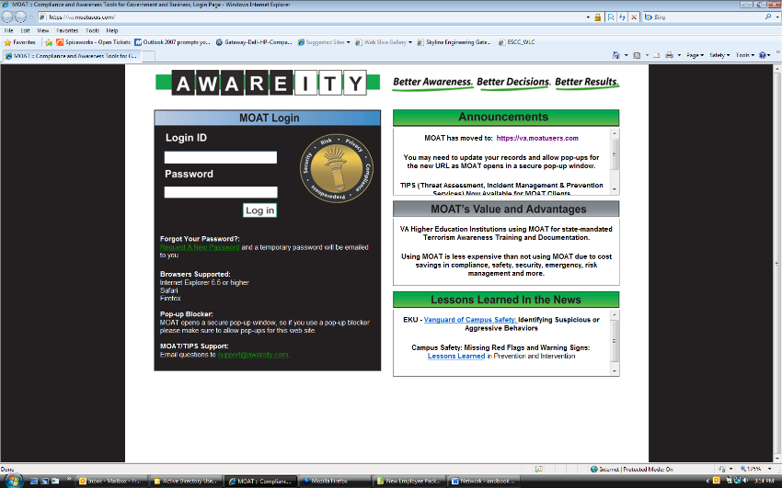The login ID will be your college email address and the password will be provided to you by email. You will be required to change your password the first time you log into the system. If you have pop-up blockers enabled in your browser, be sure to disable them before logging in.

On first logging in, you will be taken to a page giving you detailed instructions on how to use the MOAT Security Awareness Training Tool.

# How to Log Into the ESCC Network

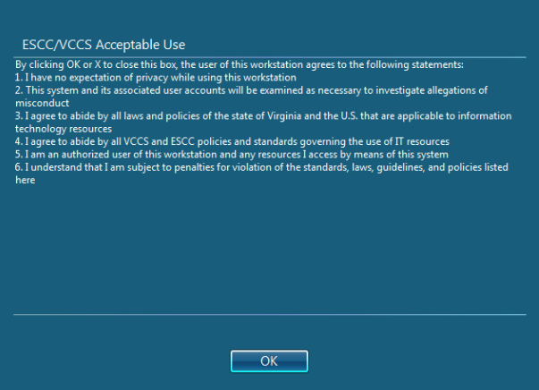

1. Press the power button on both the monitor and the system unit.
2. After a few seconds, you should see the Windows startup information, followed by a dialog box similar to the one shown at right.
3. After you click the OK or close button, the Windows login screen should appear.
4. Type your User name in the box labeled “User Name” and press <tab> or click the mouse to move to the password box.
5. In the box labeled “Password”, enter your password. You will not see the characters as you type, only dots that hide your password from other users, so type carefully. If this is the first time you have logged in, put in the temporary password you were assigned.

**Tips**

* **Don’t forget that the password is case sensitive! You must use an uppercase E and a lowercase S.**
* **If you use the numbers on the keypad on the right side of the keyboard, check to make sure the <NumLock> key is on.**
* **When creating a new password, use tricks like using a digit zero in place of the letter “o” or the digit three instead of an “e” in a word or phrase you can remember.**

1. Enter your new password when prompted. You must enter exactly the same thing in both boxes to verify that you typed what you think you typed. You will be required to use a strong password (one that is not easily hacked). Your new password must be at least 8 characters long, and must contain a mixture of at least three of the following: uppercase letters, lowercase letters, digits, special symbols (like !,@,#). Here are examples of acceptable passwords: Joe’s1stpassw0rd, mYd0gspoT.
2. You will see a dialog box when your password has been changed. Don’t forget what you entered for your password!
3. After a few seconds, your account should be ready to use.

# How to Connect to a Network Share

A network share is a folder on a server that has been designated as accessible by one or more users of the network. Some shares are available to everyone, and others are restricted to particular users or groups. Here is a list of some of the shares currently available to the users at ESCC:

|  |  |  |  |
| --- | --- | --- | --- |
| **Share** | **Contents** | **Drive mapping** | **Who can use** |
| Users | Folders belonging to  individual network users | \\admin02\home*yourusername* | The individual  to whom the folder belongs |
| Public | Folders containing  publicly available programs and files | \\admin02\public | ESCC  employees |

There are many other drive shares in use by academic programs. If you have any questions about setting up or using a share in your department or program, please come by and see IT in room A50.

Connecting to a network share is like adding a new hard drive to your machine, except that you don’t have to open the case. The instructions follow:

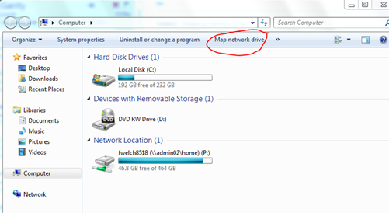

* 1. To map the network drive you'll need to go to Computer on the start Menu. Then select map network drive at the top of the window.
  2. In the top drop-down box, select the letter of the drive you want to use. In most cases, it does not matter what letter you select.
  3. 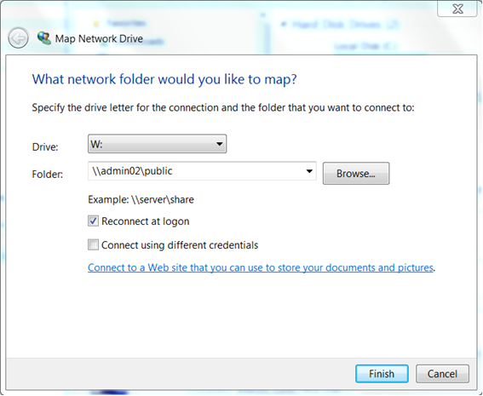Type the path to the share to which you want to connect in the text box labeled “folder.” In this example, the path is the public folder on the admin02 server.
  4. Leave the “Reconnect at logon” box checked if you always want this drive to show up on your computer. If you only want to attach this time, uncheck the box.

See the example at the left.

* 1. After you click the “Finish” button, the drive should show as another drive attached to your machine. Use it like you would any other disk drive. What you are allowed to do

(read or write files) depends on your group membership on the network and which folder you are in.

# How to Log Into My ESCC

In order to access VCCS enterprise systems like Blackboard, SIS, AIS and HRMS, you will need to log into My ESCC at [http://es.my.vccs.edu](http://es.my.vccs.edu/). You can also access My ESCC on the college’s homepage from the My ESCC link at the top of the page.

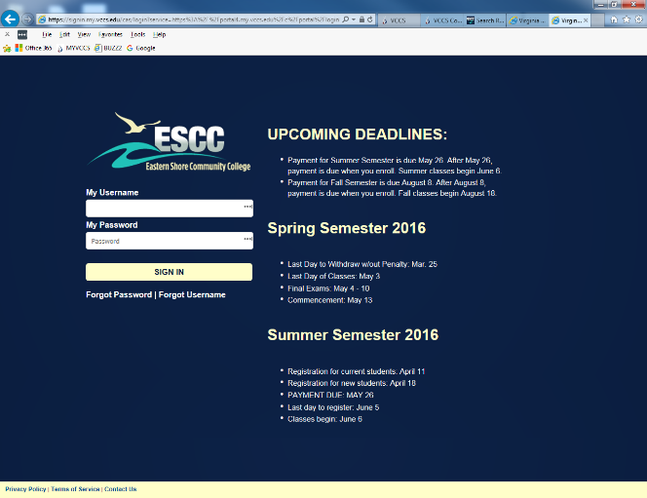

* 1. Fill in the requested information. Select Forgot Password or Forgot Username and follow the instructions provided if needed.

Please note that it can take up to 10 minutes for a password change to be applied to SIS, HRMS, AIS, Blackboard, etc.

Additional questions or assistance, contact Jay Welch, (757)789 1788.