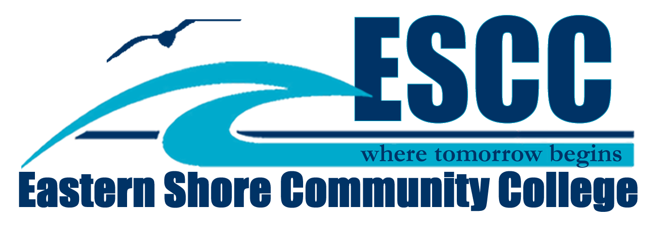

Entry Form
Entry Number: (Will be assigned when registering at the Fair.)
Student Name:
Address:
Phone Number:
Parent/s Name:
School: Grade:
Teacher:
Project Title:
Does your project deal with environmental issues?
Please return this form to your teacher or you may also mail the form directly to:

Robin Rich-Coates
Eastern Shore Community College
29300 Lankford Hwy.
Melfa, VA 23410

Deadline: Friday, April 17, 2015
Questions: Robin Rich-Coates at 789-1726 or rrich-coates@es.vccs.edu

